**Abstract**

For this laboratory assignment, we completed a surface mount practice soldering kit known as the Elenco SM-200K to become familiar with soldering and populating a simple printed circuit board.

**Introduction**

In this introductory lab we used a Kendal 899 D+ soldering iron and other associated tools. The Elenco SM-200K kit is a PCB that introduced us and gave us experience in surface mount soldering. The kit had us solder capacitors, resistors, ICs, LED’s, diodes, transistors, a battery snap and a buzzer to a circuit board. Before starting the lab, a checklist was used to ensure no parts were missing. Parts were also made sure to be the correct measured value. After soldering, the solder joints were examined and critiqued. The objective of this lab was to develop soldering and other related skills as well as following through a test procedure and evaluating our performance.

**Appendix**

**Figure 1 –** Elenco SM-200K Kit

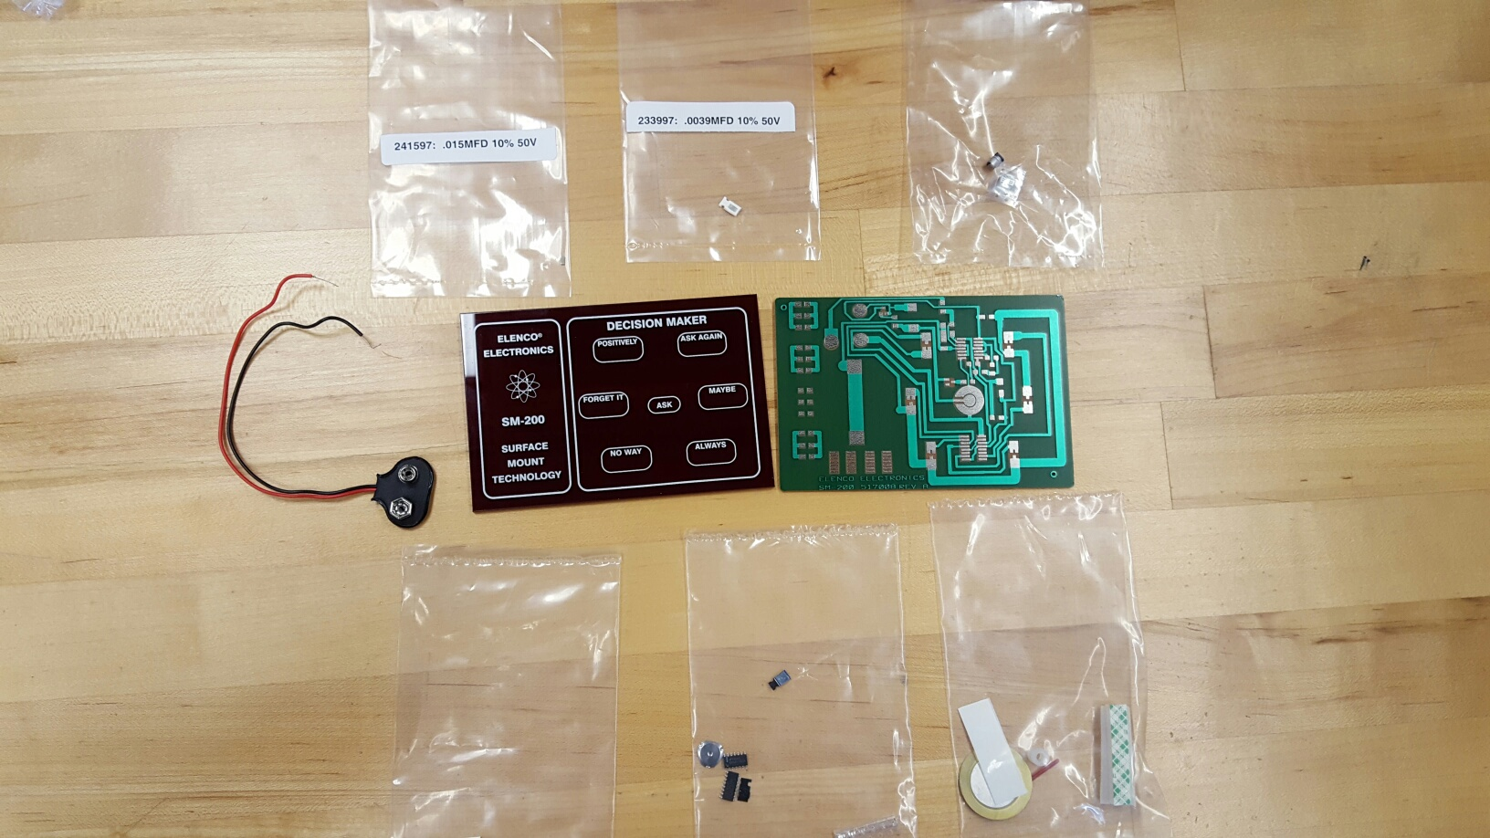

**Figure 2 –** IC 4011 soldered at the top of the board

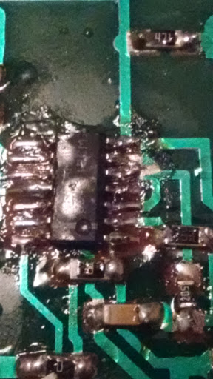

**Figure 3 –** IC 4017 soldered at the bottom of the board

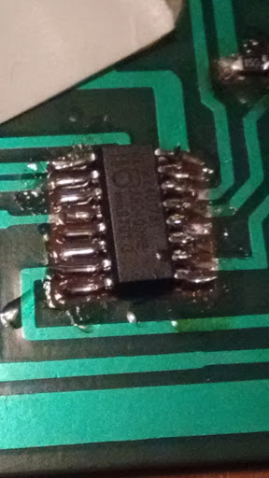

**Figure 4 -**  Completed PCB

